**Title: Career Services**

**Group Number: 83**

|  |  |  |
| --- | --- | --- |
| First Name | Last Name | Online Students? (Yes or NO) |
| Siddharth | Singh | NO |
| Prateek | Deshmukh | NO |
| Vighnesh | Sawant | NO |

Table of Contents

**1. Introduction and Motivations** 2

**2. Requirement Analysis** 2

**3. Database Design** 2

**4. Application Design** 2

**5. Demos** 2

**6. Conclusions and Future Work** 2

6.1. Conclusions 2

6.2. Limitations 2

6.3. Potential Improvements or Future Work 2

**7. Deployment** 2

# **1. Introduction and Motivations**

**Introduction**:

- The project is aimed at developing an offline application for career services of Illinois Institute of technology. It can be accessed throughout the org.

- This system can be used as an application for the career services of the university to manage the student info with regards to co-op, internships and full-time jobs.

- With the help of student login, they will be able to upload the info and can generate cv automatically.

- Employers can also log into the system and can search candidate profiles based on their request.

- It is centralized repository of student’s profile

- Also, students will able to view employers list along with positions they are offering.

- The hybrid recommender systems exploit the jobs and user profile to generate personalized recommendation of jobs for candidates.

- All student data will be warehoused according to year and department

- Companies will disclose positions and job availability to career fair services

- Eligible student can apply for the job based on the criteria provided by the company.

- Student can give pre- aptitude test before the interview through electronic exam in the software

- When a student logs into the account, he/she can see their status.

**Motivation**:

- This project was aimed for giving services to not only students but also employers.

**2. Requirement Analysis**

**Database Planning**:

- collected student’s data and warehoused from his 1st year to final year.

- ERD – ER diagram will show the relationships between students, admin, website and companies.

- UML provides a standard way to visualize the design of a system, where in admin, TPO, student, teacher, admission admin are the actors.

- It further identifies several types of users in the system and their different use cases i.e. what kind of operations the user is going to perform in the system.

- Sequence Diagram of a system shows how processes operate with one another and in what order. Also shows object interactions arranged in time sequence.

- State Website Diagram of our system.

- Data Flow diagram of our system shows graphical representation of the flow of data through an information system, modelling its process aspects.

- Gantt chart illustrates the timeline of the project.

**Design and implementation** – System Design helps in specifying hardware and system requirements, also helps in defining overall system architecture

**Web programming language**:

- PHP is a server-side scripting language designed for web development but also used as a general-purpose programming language.

- Hyper Text Markup Language, commonly referred to as HTML, is the standard markup language used to create web pages.

- Along with CSS: Cascading Style Sheets (CSS) is a style sheet language used for describing the presentation of a document written in a markup language. JavaScript: JavaScript is a high-level, dynamic, untyped and interpreted programming language.

- MySQL is a relational database management system (RDBMS) that runs as a server providing multi-user access to many databases.

- Wamp Server will install Apache, PHP5 and MySQL on your Windows system. Wamp Server comes with a service manager as a tray icon. It will allow you to easily manage your server. The WAMP stack provides developers with the four key elements of a Web server: an operating system, database, Web server and Web scripting software. The combined usage of these programs is called a server stack.

**System definition**:

- Developed portal for Career services which is the desktop based application.

- Within the system, maintained students records in proper formats and eliminated the tedious job of shortlisting the selected students, eligible for the company.

- Granted privileges to make changes only to the authorized administrator.

- Eliminated the process of proof reading of student's CV and paper works.

- Inclusion of filter for campus selection of only IIT students.

- Incorporated levenshtein algorithm to match the student's criteria.

**Scope and boundaries of the project**:

- Storing information of all the students.

- categorizing Resumes according to various streams.

- Automatic generation of Resumes/CVs.

- Notifications feature to send out updates to students regarding the career fair and employers.

- Incorporated offline services to save data and time from Employers and Student’s perspective that can be accessed throughout the organization and outside as well with proper login provided.

- System can be used as an application for the college authorities to manage the student information with regards to placement.

- Home page connects with numerous services like events happened, achievements and recruiter details etc.

- Creation of users only through Administrator. Only the students from IIT college will be allowed to create accounts.

- All the users share some common services like changing password, updating details, searching for details, checking the details, mailing to administrator, and reading the material uploaded by admin if the user is a student.

- Administrator will be provided the privileges of adding events, achievements and can reply to the mails sent by different users. He/she can upload materials, search for student details, and will be given permission to approve the students.

- Eliminated typical issues of manual examination processes and activities into a controlled and closely monitored work flow in the architecture of the application. This solution brings in by default, the basic intelligence and immense possibilities for further extension of the application as required by the user.

- The system makes it simpler to distribute, share and manage the examination entities with higher efficiency and easiness.

The AIM of making this website to serve as a common meeting ground for job seekers and employers, both locally and globally, where the candidates find their dream jobs and recruiters find the right candidate to fulfill their needs.

# **Requirements Collections and Analysis**:

# - Implementation Software Development Life Cycle.

# - Incorporated Agile Approach for making it very easy to adapt when some requirements change.

# - Employed Unit Testing for Development and Testing of each unit for its functionality. Unit testing mainly verifies if the modules/units meet their specifications. These units are integrated into a complete system during Integration phase and tested to check if all modules/units coordinate between each other and the system behaves as per the specifications.

# - Operational Maintenance: If new attribute needs to be added anywhere in the system, then admin must update it. Also, issues related to the system are solved after deployment of the system. Not all the problems come in picture directly, but they arise time to time and needs to be solved hence this process is referred as Maintenance.

# **3. Database Design**

Follow the three stages to design database

* The system will involve the use of a lot of information on the basis of the requirements and the most appropriate form of storage of this data is in a database.
* We have chosen the MySQL database for storing data because database has proved to deliver high integrity of data storage.
* MySQL database has successfully featured the four properties that all database systems must have: atomicity, consistency, isolation and durability.
* The MySQL provides a reliable and competent database system.
* This database has many features, that give security, protection, maintenance and reliability.

# **4. Application Design**

# 1. In this project:

# - Students, Employers, Career Services, Administrator acting as users.

# - Involvement of different modules within a single platform architecture as admin and other users (Student, career services).

# Administrator module consists following services:

# - Update details: Allows Administrator to update his/her (University) details.

# - Update statistics: Allows Administrator to insert/update statistics like number Of students selected etc.

# - Add student: Allows Administrator to add a student to database.

# - Add recruiter: Allows Administrator to add a recruiter to database.

# - Add event: Allows Administrator to add/insert an event.

# - Approve: Allows Administrator to verify the details of the student, and to Approve him /her to the application if they are correct.

# - Student details: Allows Administrator to search for student information According to eligibility criteria for recruitment process.

# - Upload material: Allows Administrator to upload material for students.

# - Mailing: Allows Administrator to reply for the mails sent by users.

# - Change password: This service enables the Administrator to change password.

# - Add Staff: Admin can register new roles such as Professor/Teaching Assistant.

# - View list of staff: Admin can view all staff list (also can edit information).

# 2. Career Services module consists following services:

# - Update details: This service provides the user to update their details.

# - details: This service provides the user to check the University details.

# - Student details: This service allows recruiter to search for student information according to eligibility criteria for recruitment process.

# - Mailing: This service provides the user to mail to Administrator.

# - Change password: This service enables the users to change password.

# - Arrangement of interview calls.

# - Sending Interview call information via mail to the shortlisted student.

# 3. Student module consists following services:

# - Update details: This service provides the user to update their details.

# - Check details: This service provides the user to check his details.

# - Material: This service provides the user to check for materials uploaded by Administrator

# - Mailing: This service provides the user to mail to Administrator.

# - Change password: This service enables the users to change password and view results.

# - Career Services Information- contains Interview call mailed-list.

# - Creation of CV- student’s details, grades, activities.

# - Add student marks

# - Add extra activities of students- events-event name, role-related to CV- just display

# 4. Registration module consists following services:

# - Filling of admission form during the time of student's admission.

# **5. Demos**

Following are the snapshots taken from the project:

1. Home Page

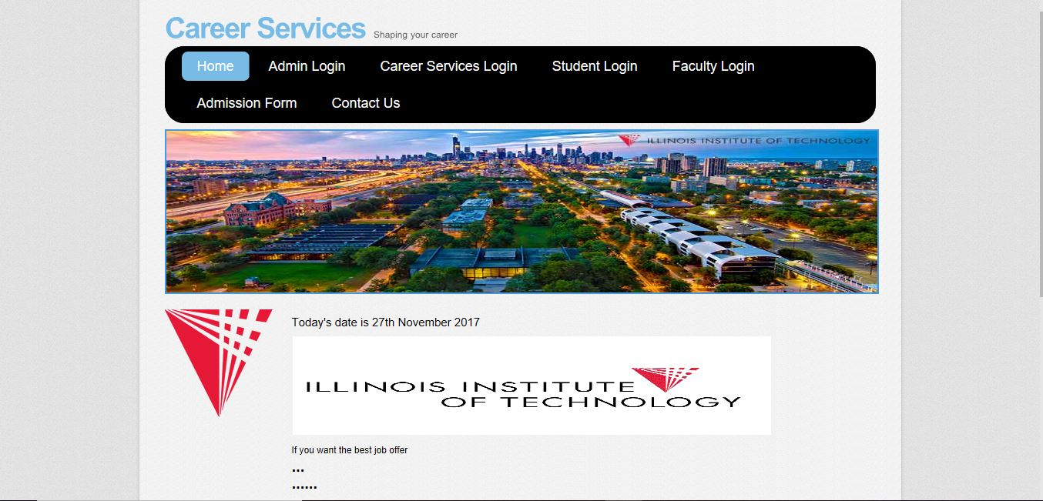

1. Admin Login

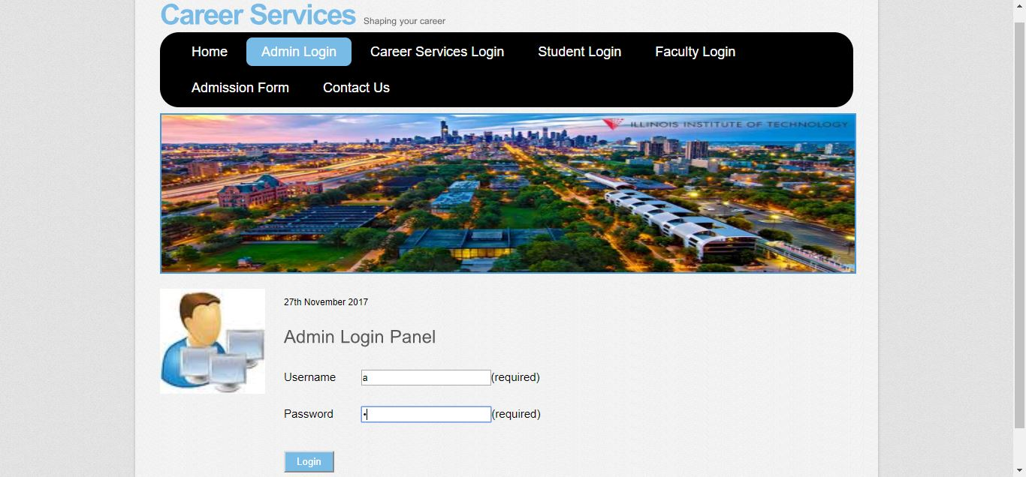

1. Admin Login (failure)

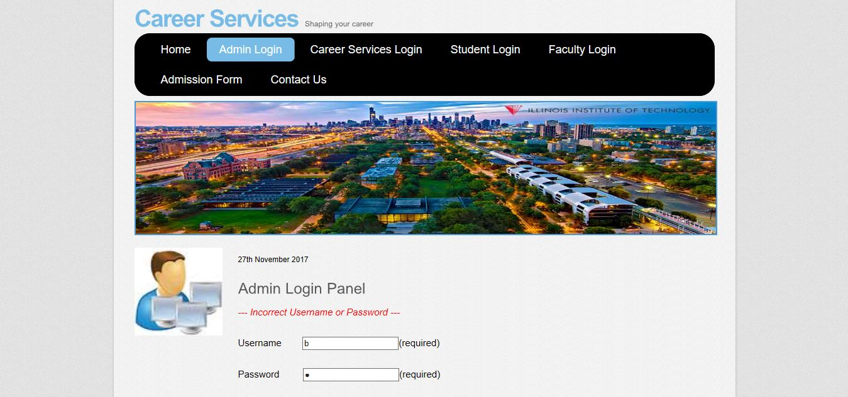

1. ADD new faculty

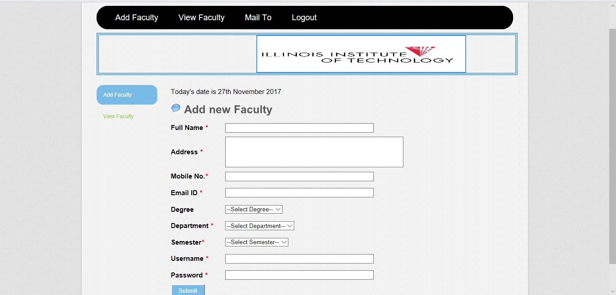

1. View Faculty

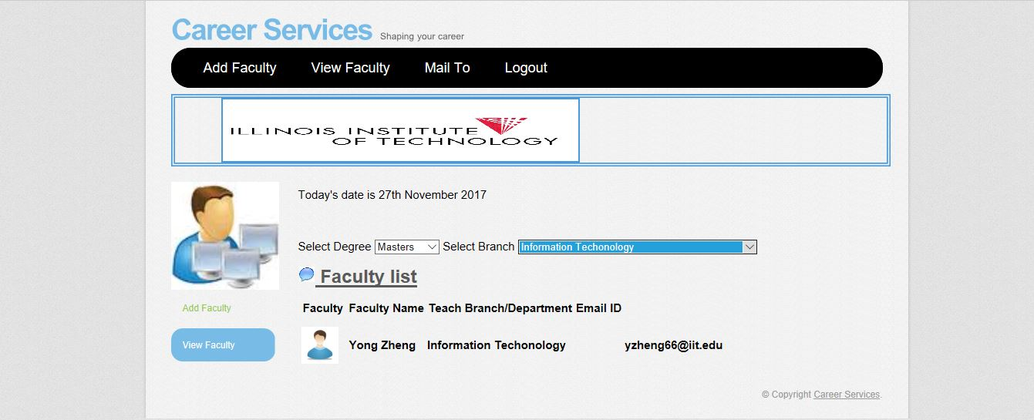

1. Career Services Login

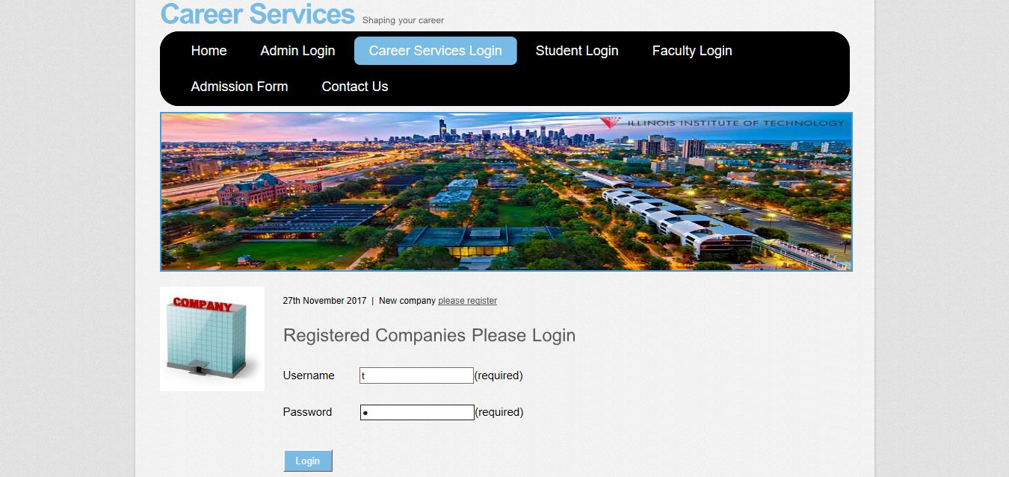

1. Registration Form for Companies

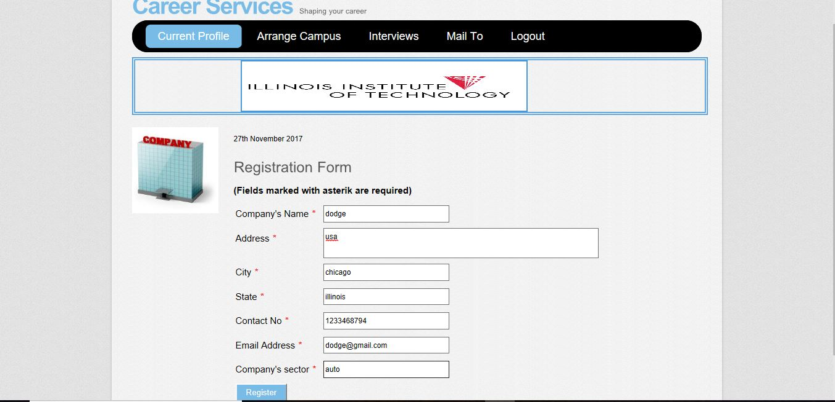

1. Arrange Campus

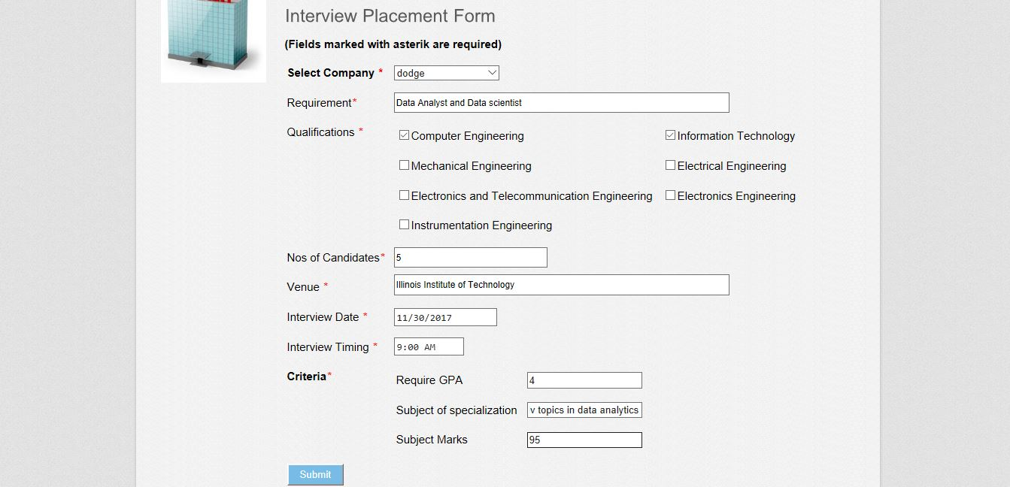

1. Job Offers

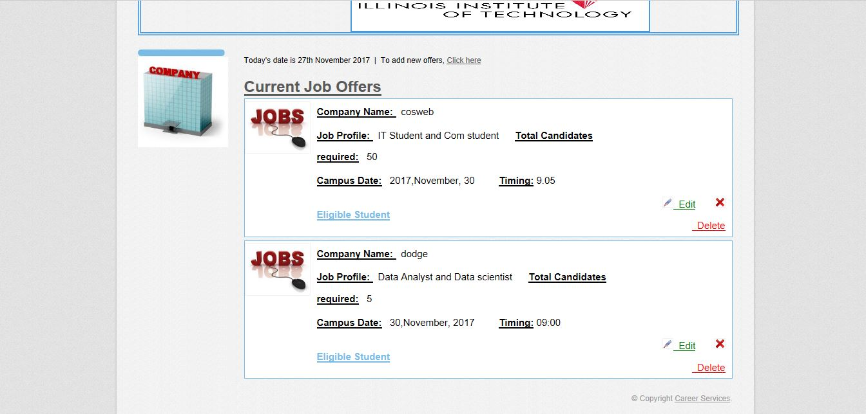

1. Eligible student

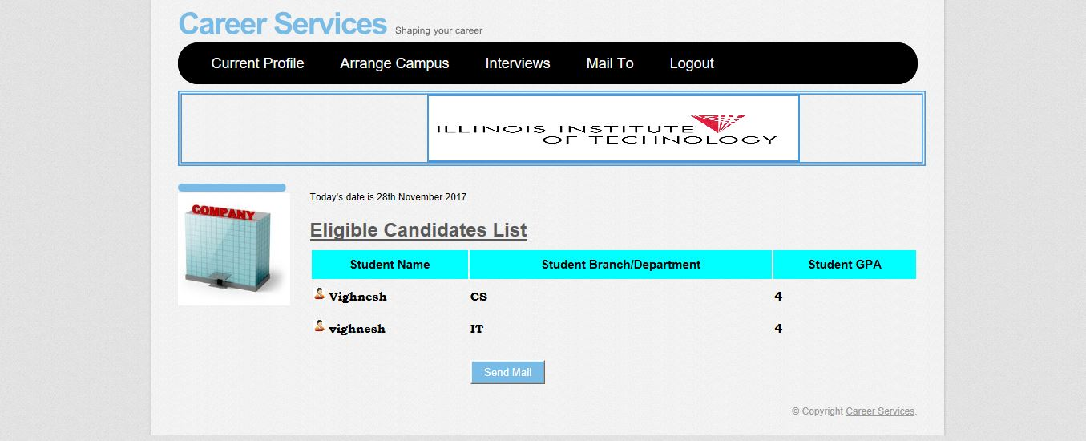

1. Mail

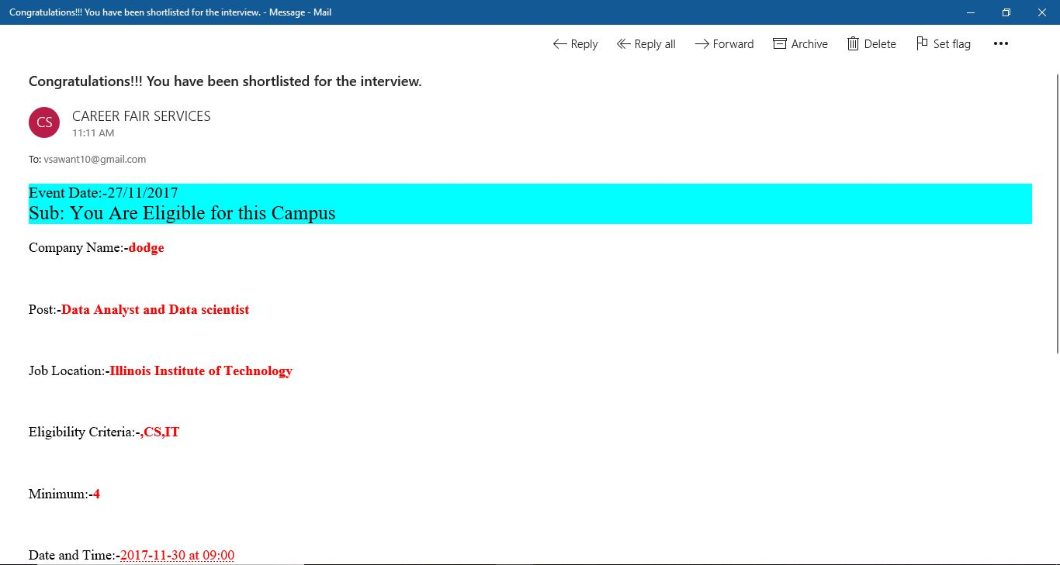

1. MAIL TO

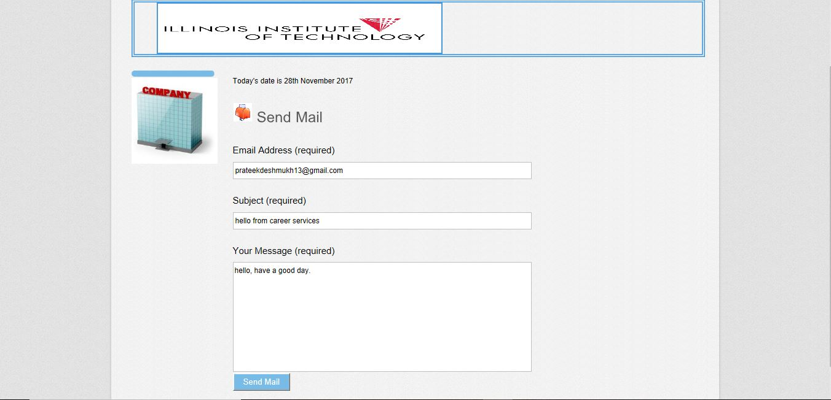

1. Mail Check

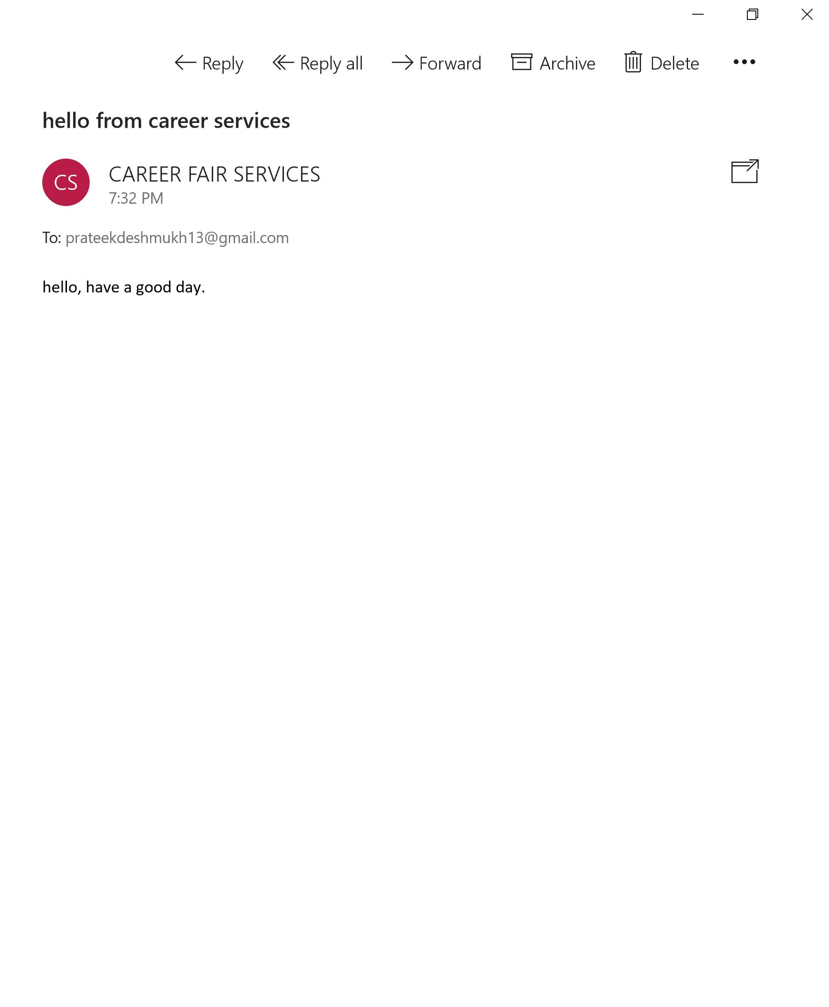

1. Student Login

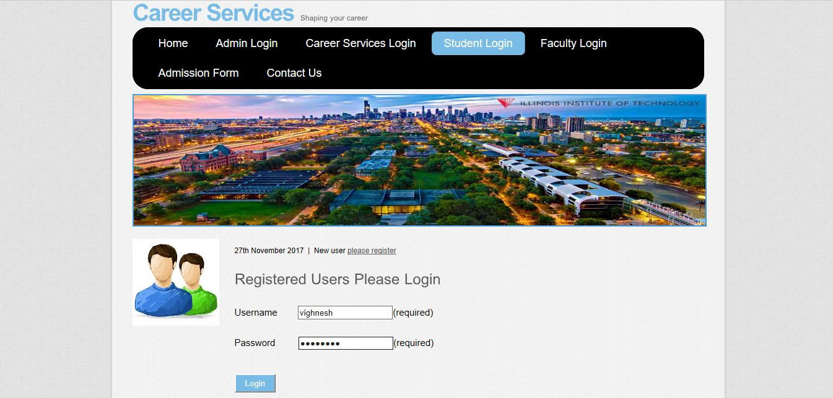

1. New Student Register

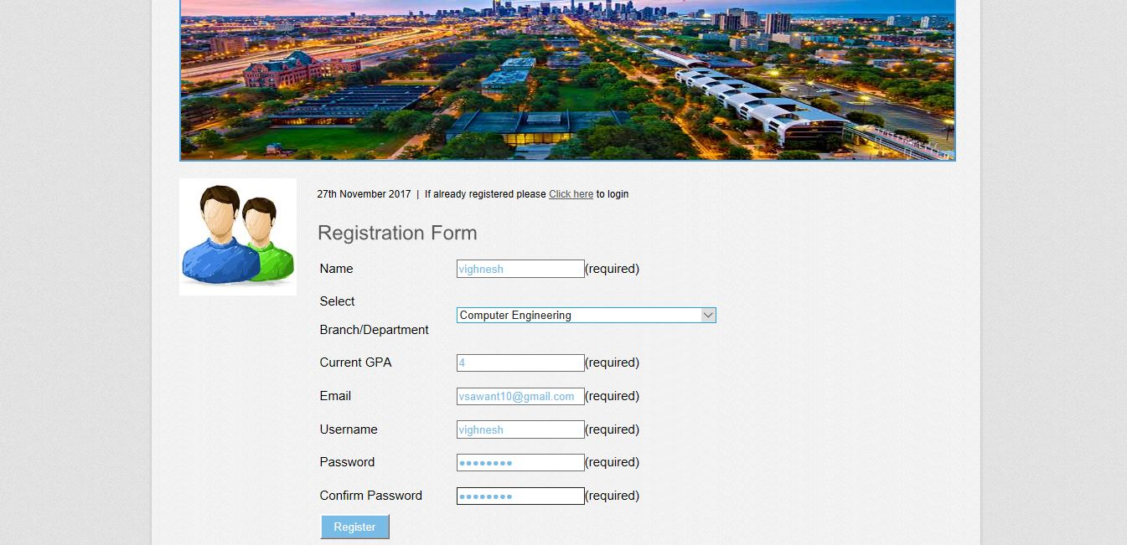

1. Registration Failed

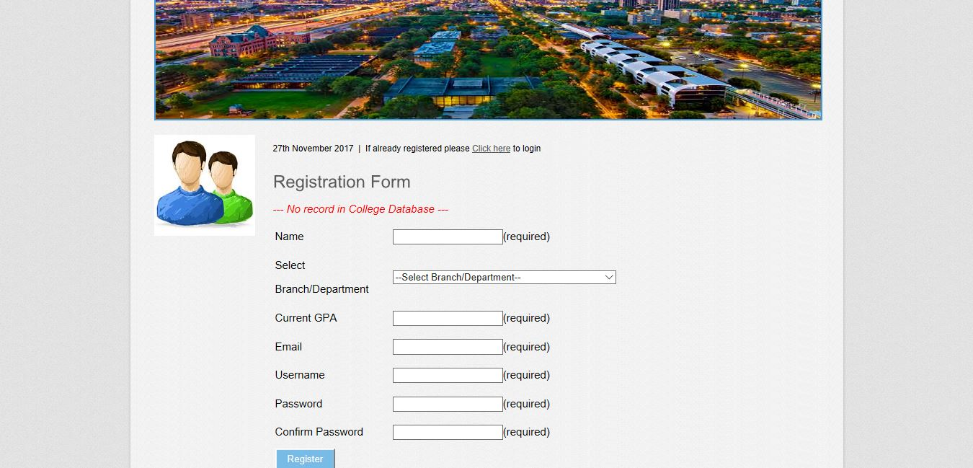

1. Eligible Campuses

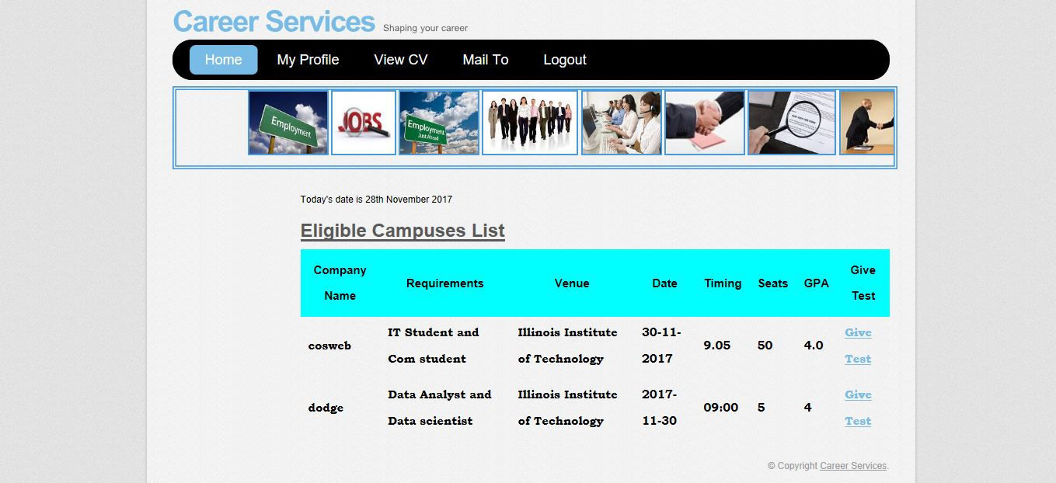

1. Test

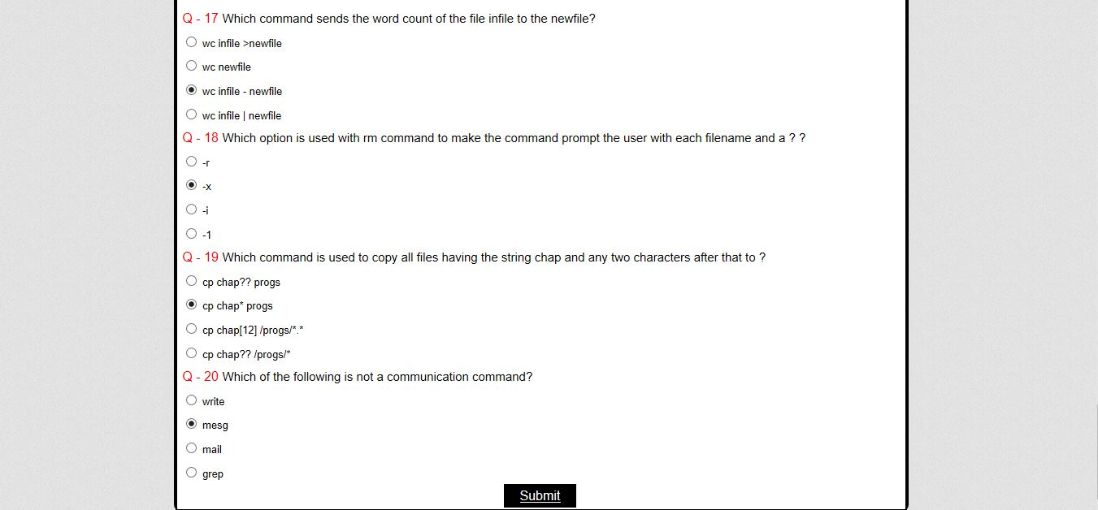

1. Result

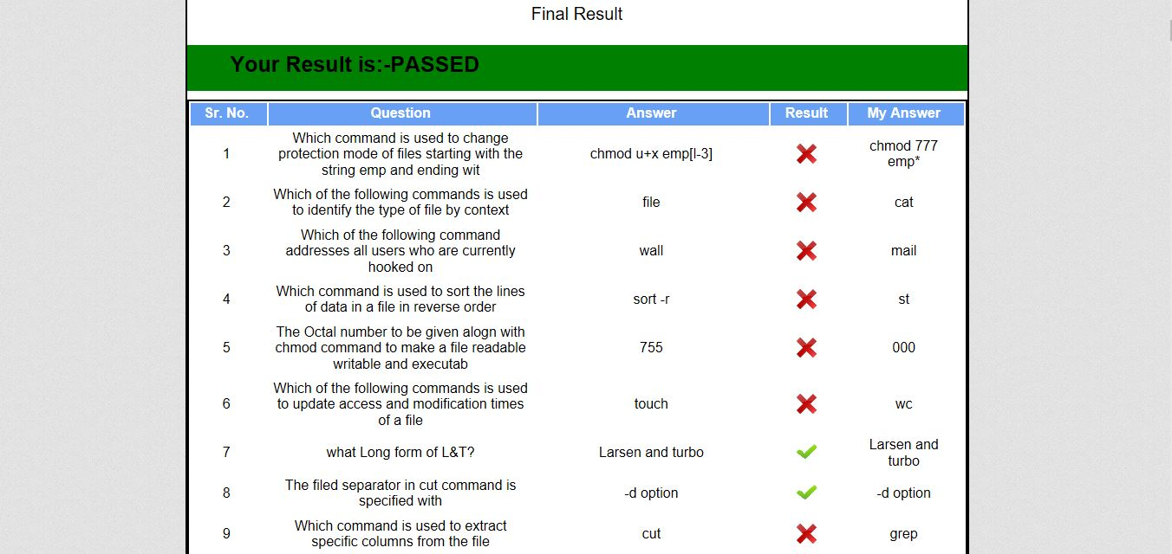

1. Student Profile

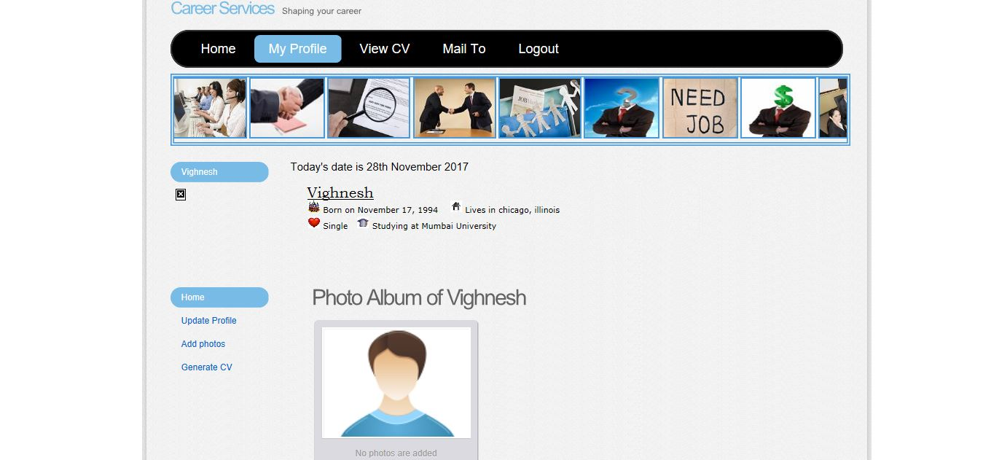

1. Add Photo

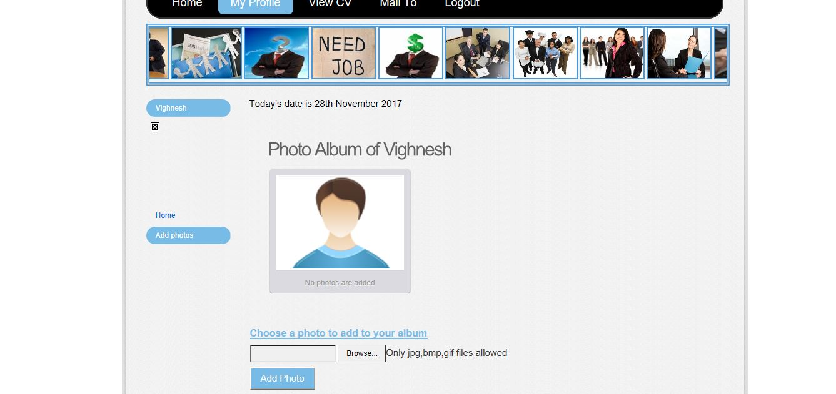

1. Updating User Profile

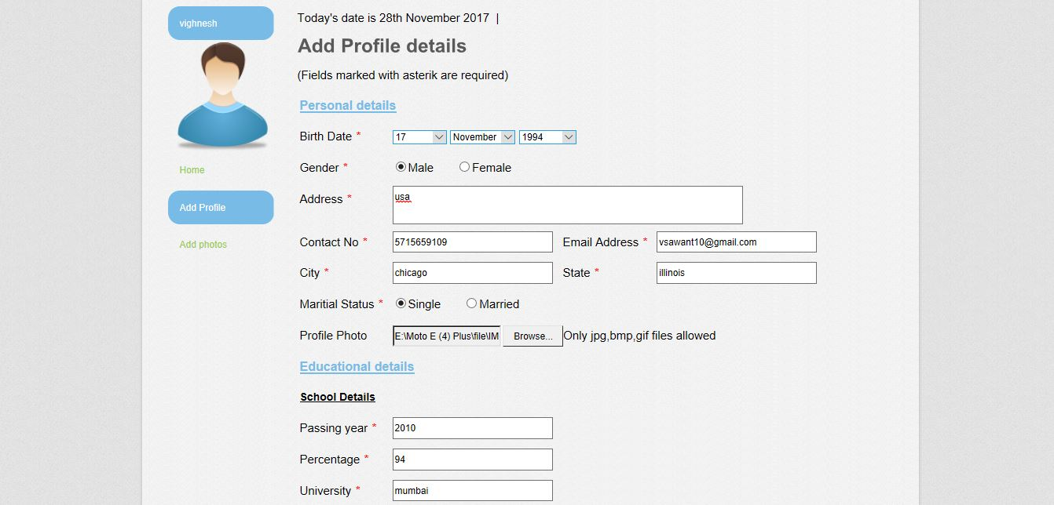

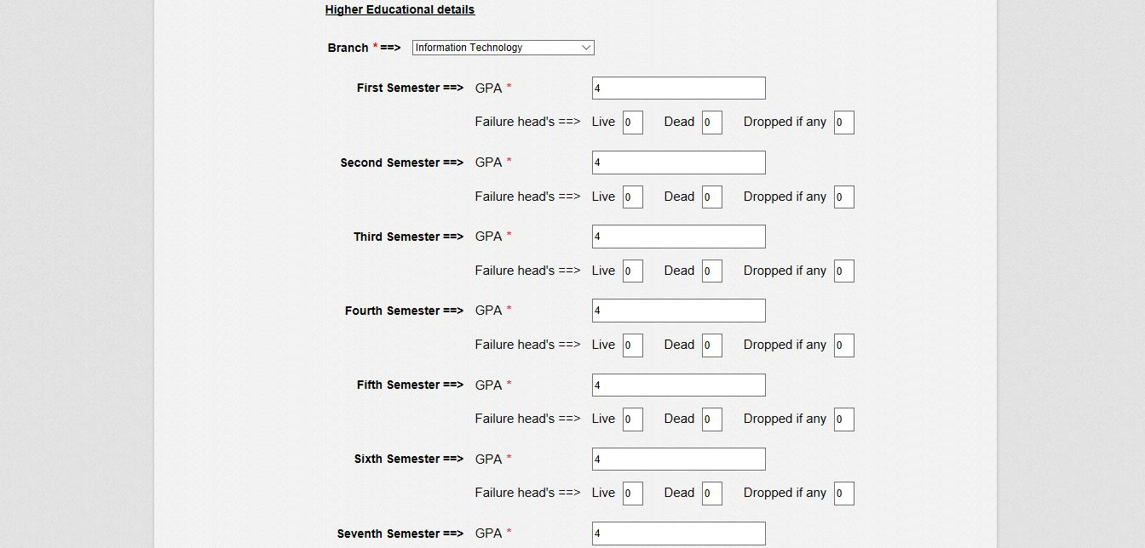

1. Generation of CV

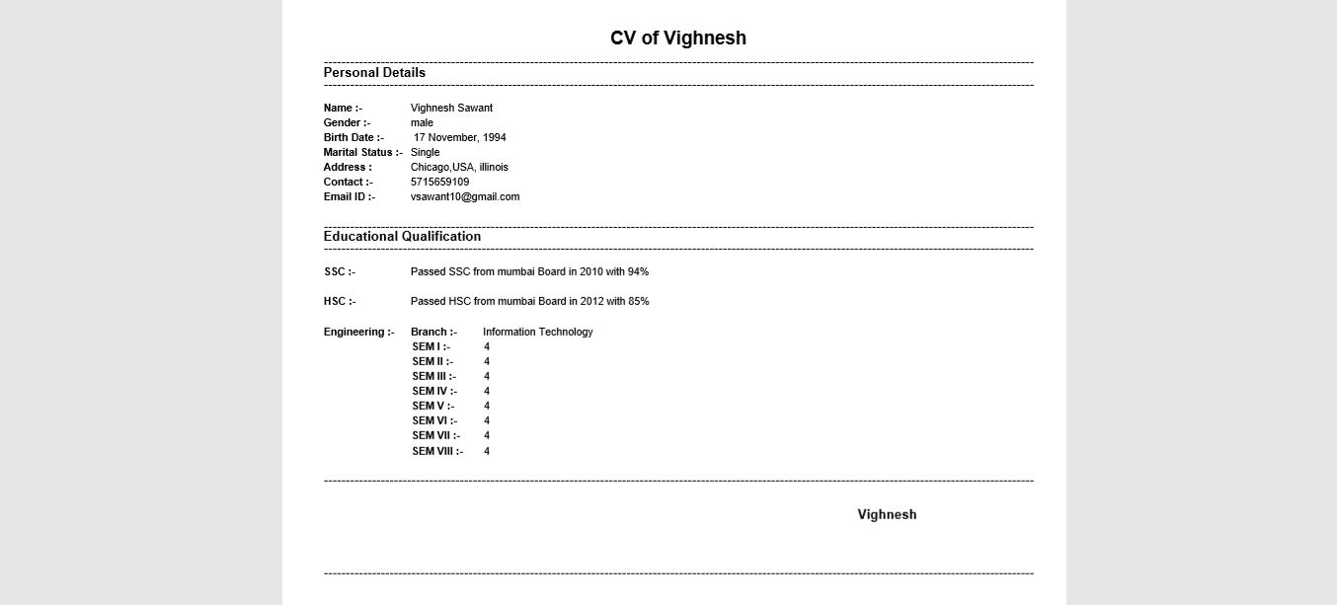

1. CV

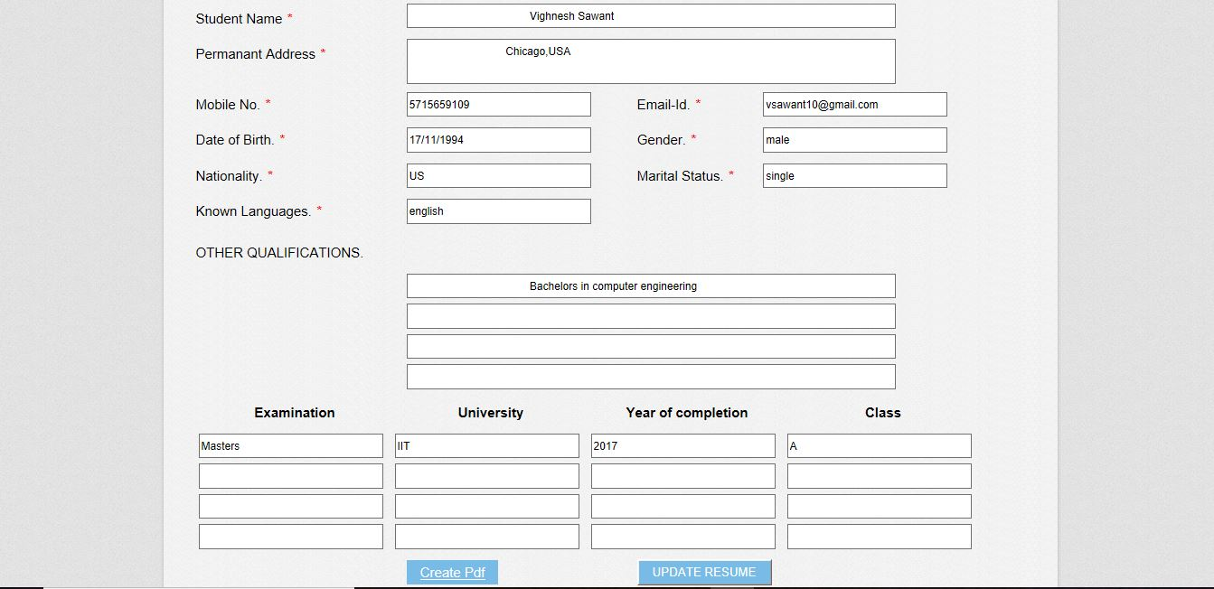

1. Faculty Login

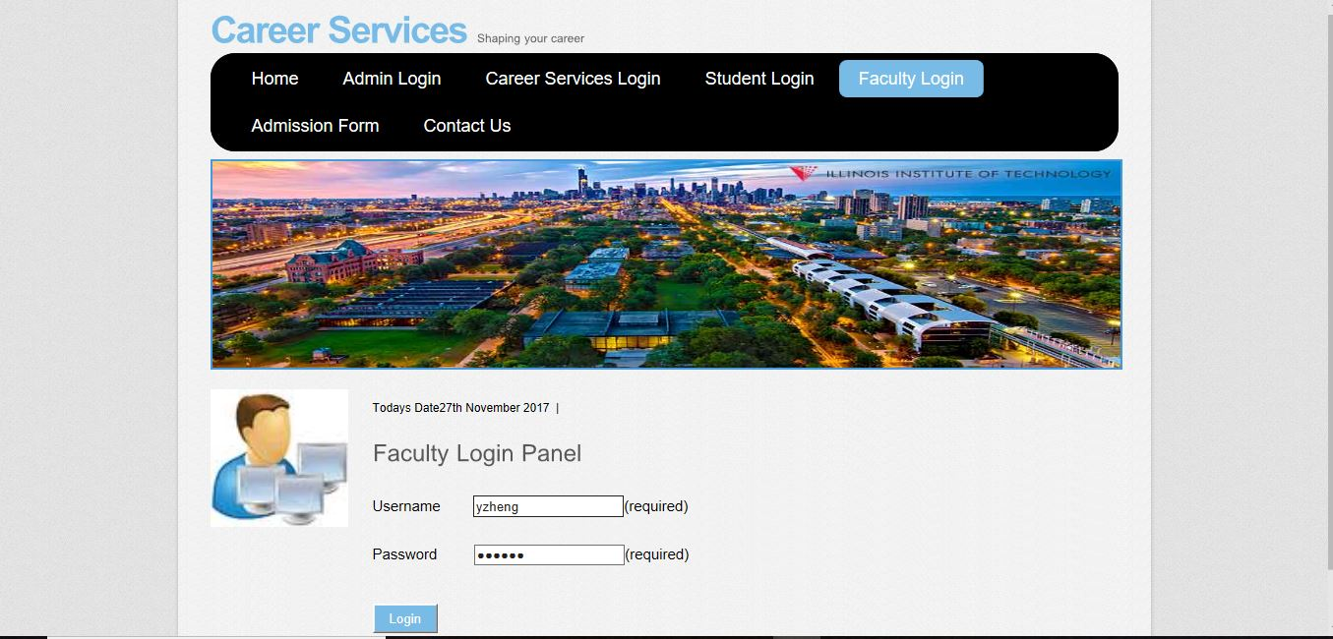

1. Faculty Login Fail

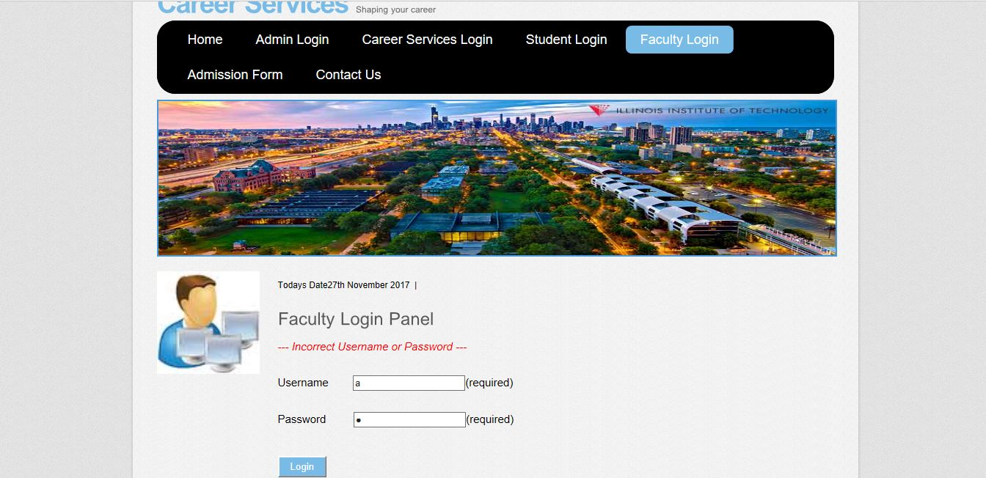

1. Faculty Profile

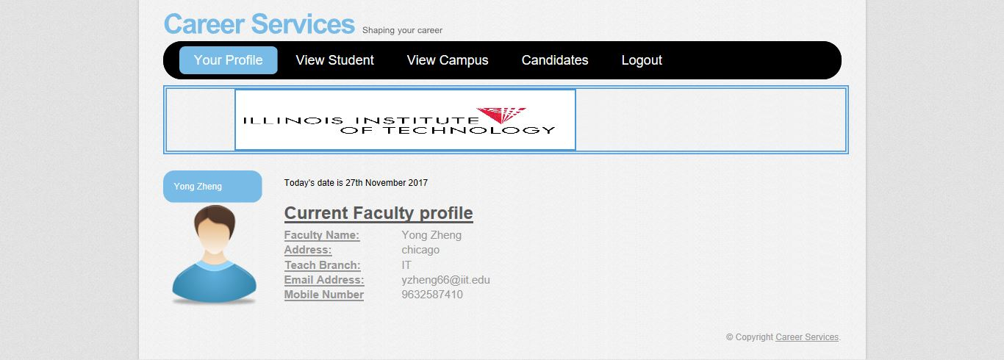

1. View Student

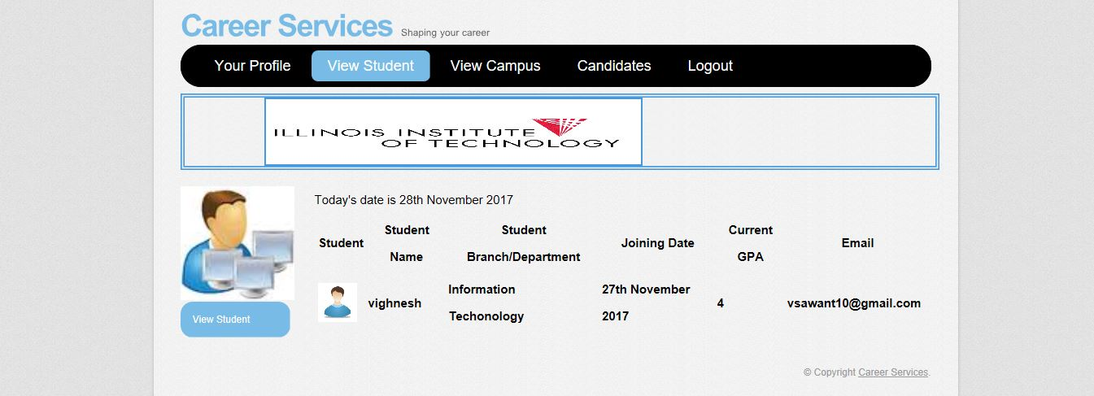

1. View Campuses

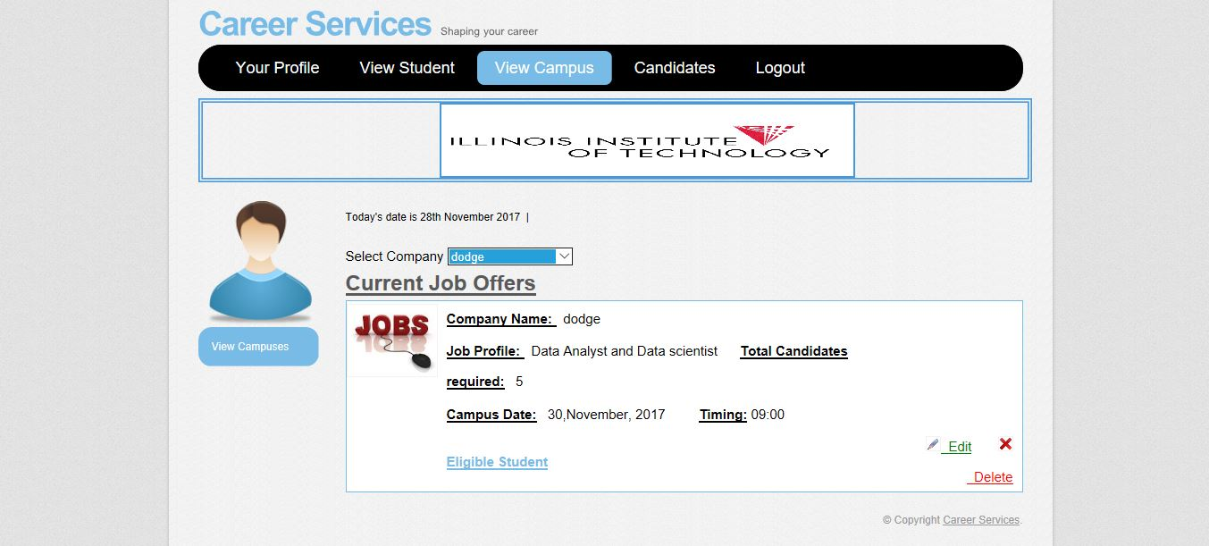

1. Eligible Students

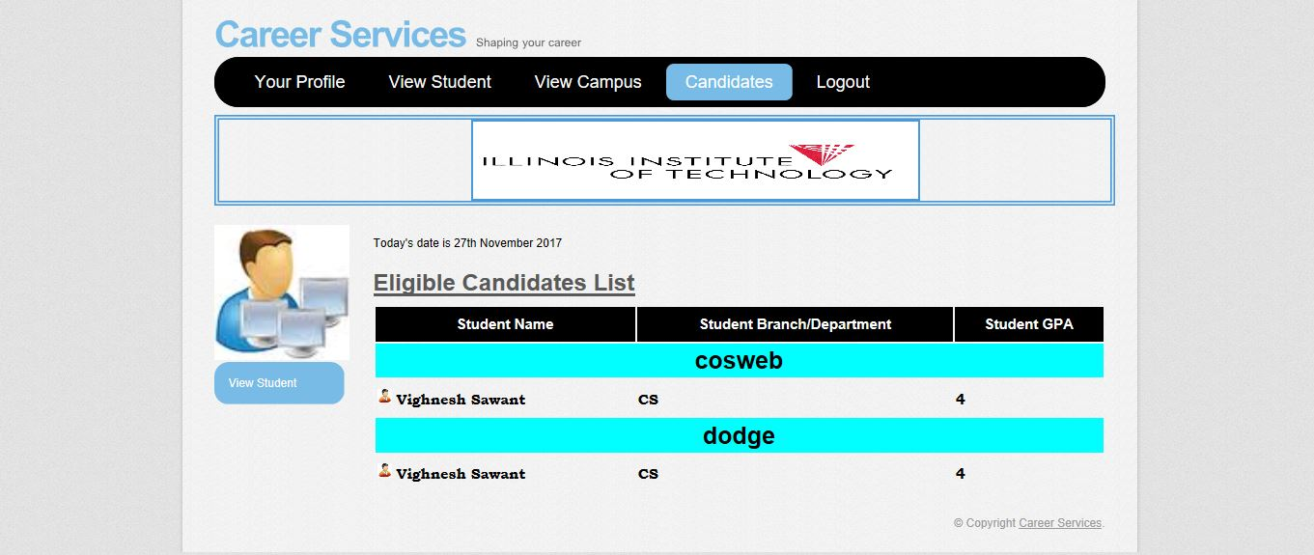

1. Admission Form

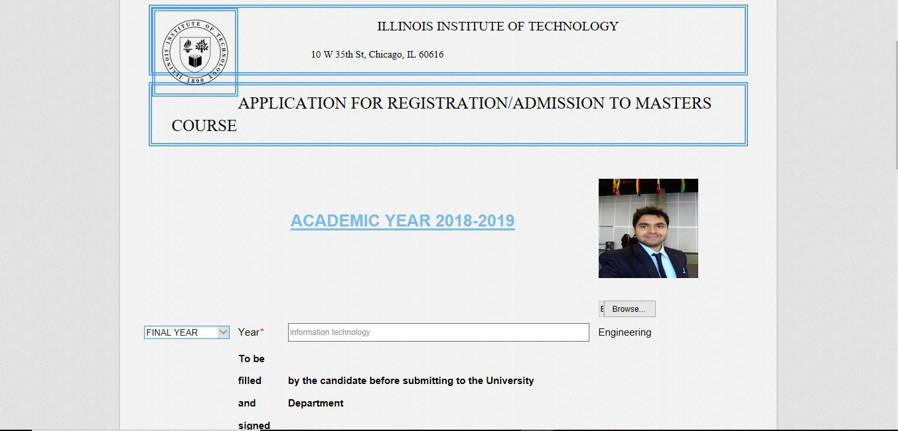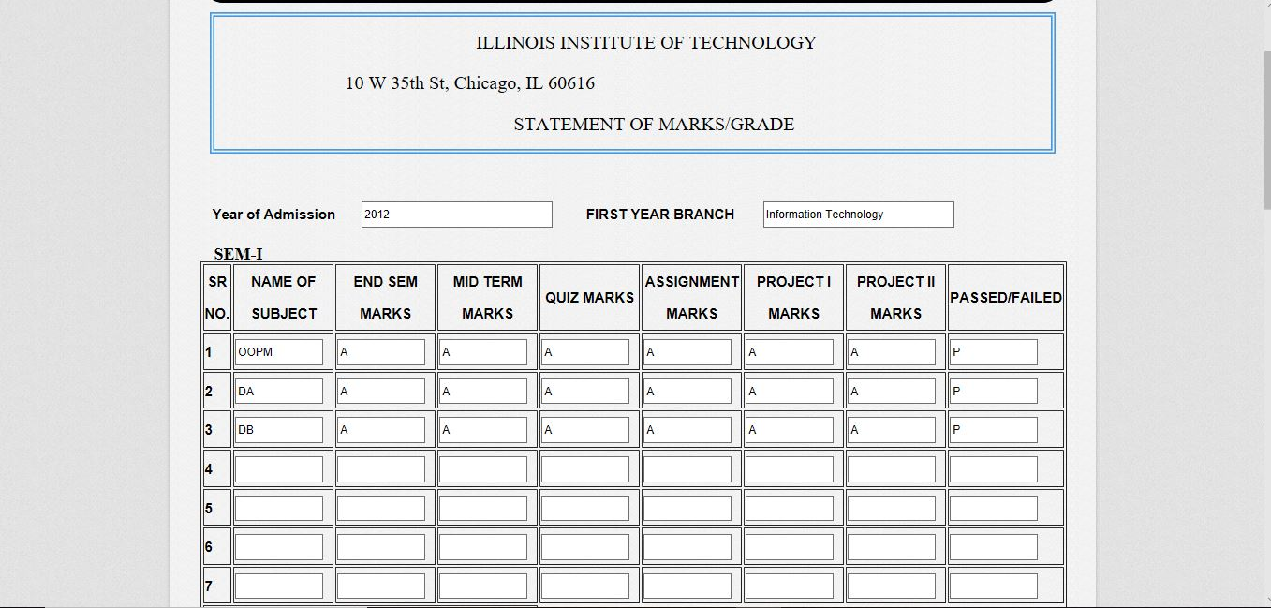

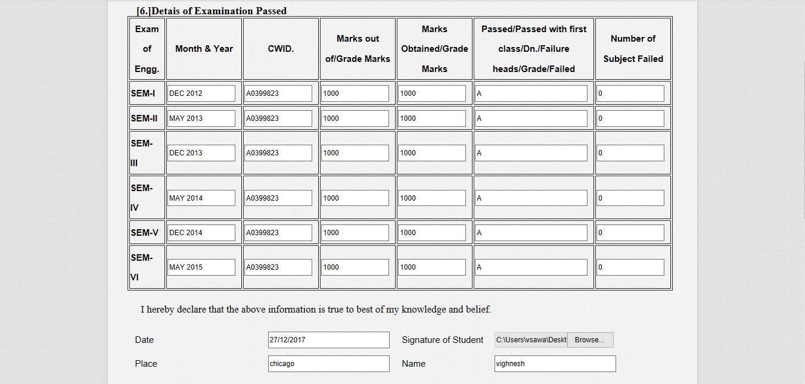

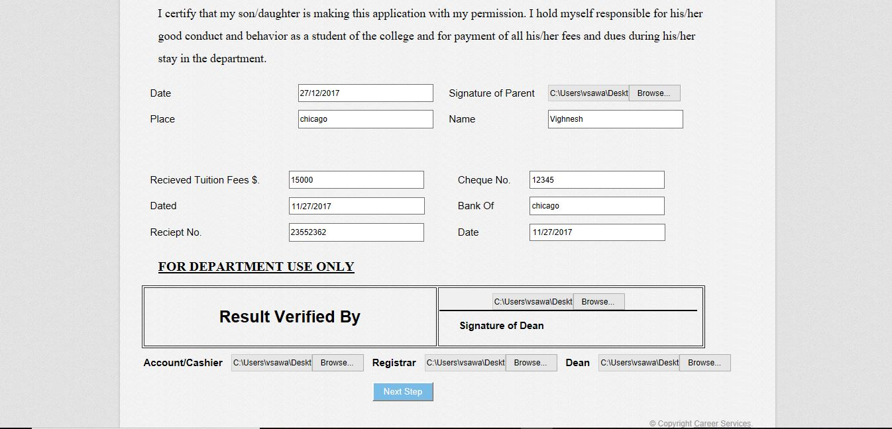

1. Contact Us

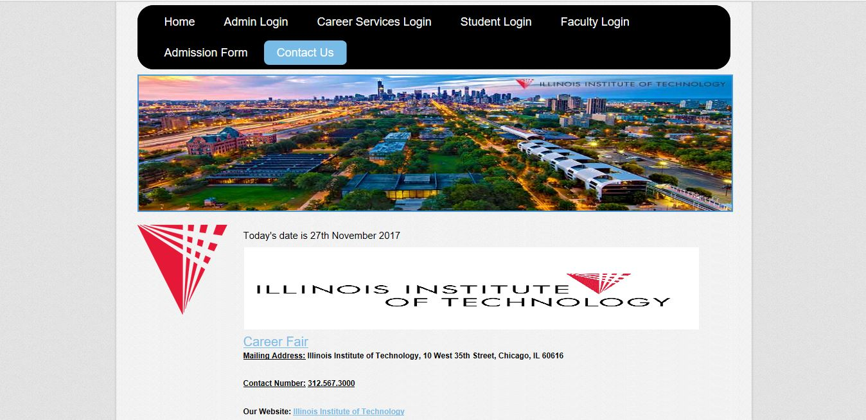

# **6. Conclusions and Future Work**

## 6.1. Conclusions

## - Overall, the entire process of Career services is automated.

## - We can achieve registration of a student, a faculty, personalization of student, communication between career services, student and the faculty.

## - Ease in shortlisting the eligible students for a campus.

## 6.2. Limitations

- Were able to send mails only for Gmail, yahoo mail and outlook domains.

## 6.3. Potential Improvements or Future Work

# - SMS integration can be provided; notifications and important notices can be sent via SMS.

# - Can place the system on cloud so that the maintenance of data is reduced.

# - Exam section/module can be consolidated with this system so that results will be directly shown to the students.

# **7. Deployment**

Image that you are going to deliver the products the customers, produce a manual for the customers to deploy your projects for practical use.

Important Notes:

1. Each team only submits a single copy to the blackboard system by a same team member. If more than 1 team members made the submissions, deduct 5 points
2. Two submissions: Report.pdf and Codes.zip. If your submissions are not in the correct format, deduct 2 points
3. You must produce your reports based on this template. If not, deduct 2 points
4. In the codes.zip, you need to include you codes (do not forget to add comments to your codes), the clear ERD figures, and the dumped database file. Whatever DBMS you use, there is a way to dump the whole database into a text file.
5. Your project will be rated by 4 sections: report, codes, presentation and value. The deducted points mentioned above, will be applied to the final total grade of your project. Not to the “report”section.